BlogEngine.NET

Capacity Test Results Report

Abbreviations and Acronyms
High | H
Middle | M
Low | L

Contents
1 OverView 4
1.1 Summary 4
1.2 Environment 4
1.2.1 Application software configuration 4
1.2.2 Application hardware configuration 4
1.3 Testing Object/requirement 4
1.4 Test Tool 4
1.5 Accept Criteria 5
2 Test Result 5
2.1 Anonymous User 5
2.1.1 Load Model 5
2.1.2 Results 6
3 Analysis Summary 10
3.1 Analyze 10

OverView

Summary
BlogEngine.NET is the web application.

Environment

Application software configuration

Application hardware configuration
CPU: 11th Gen Intel i5-1145G7 @ 2.6GHz

Memory: 24GB

Testing Object/requirement
Increase in the number of users and data to the server, collect all the test result during the system under pressure. Measure the performance as below:
- Measure front-to-end response time for capacity testing environment
- Measure the error rate for capacity testing environment
- Measure the resource usage on server
- Get the saturation point

Test Tool
Client Side：Jmeter

Accept Criteria
Name | Standard
User response time | Scene | User tolerance time
User response time | Simple | 2< 3 <5 seconds
User response time | Complex | 3<5 < 7 seconds
Request success rate | 100 %
CPU | <70%
Memory | No memory leak

Test Result

Anonymous User

Load Model
Precondition: None
Ramp-up time (think time): 10s
Testing Time: 120s
Step:
User Profile/Workflow:
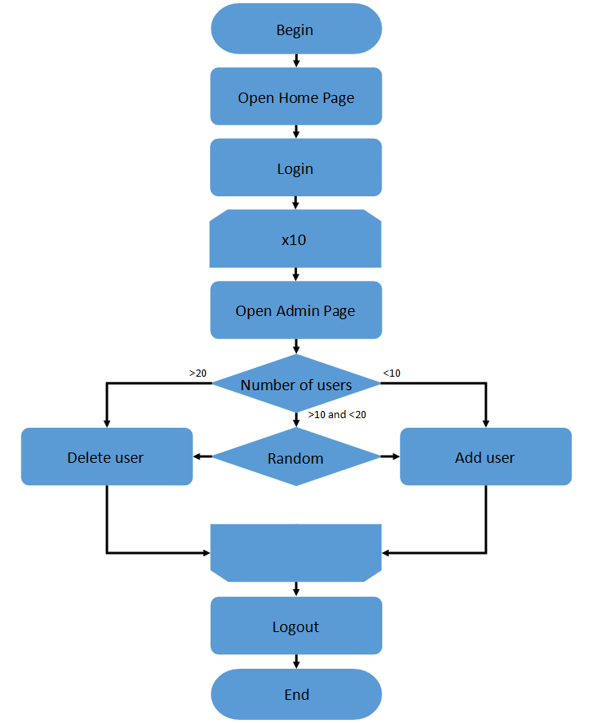

Results
1 user:
Smoke Test
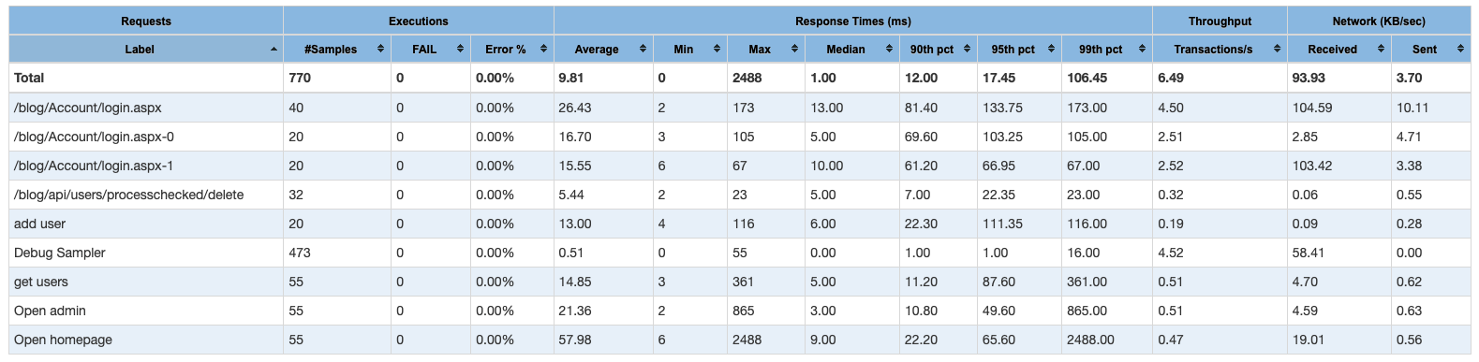

10 users:
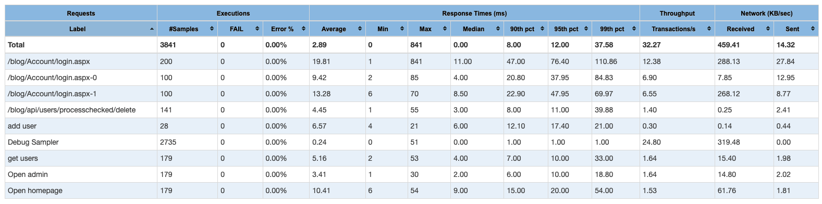

20 users:
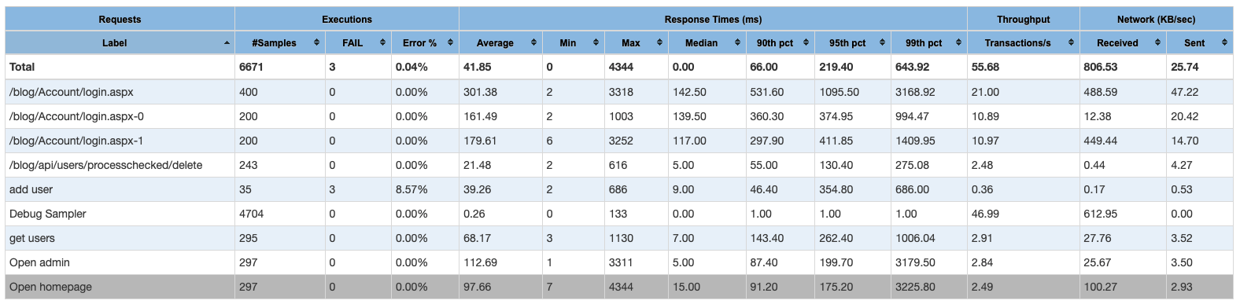
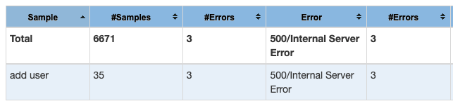

30 users:
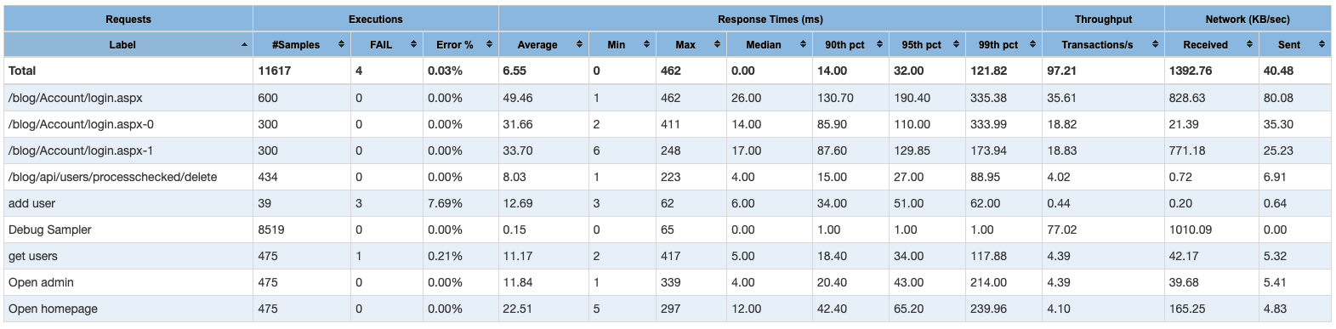
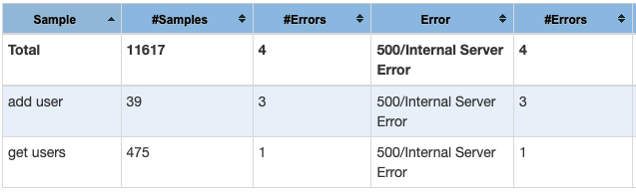

Analysis Summary

Analyze
The system works well under smoke test, but got 500 internal server error @20 & 30 threads.

REVISION HISTORY
Ver. | Description of Change | Author | Date | Approved
 |  |  |  | Name | Effective Date
<1.0> | Initial | Samuel Shen | 28-Mar-2022

